
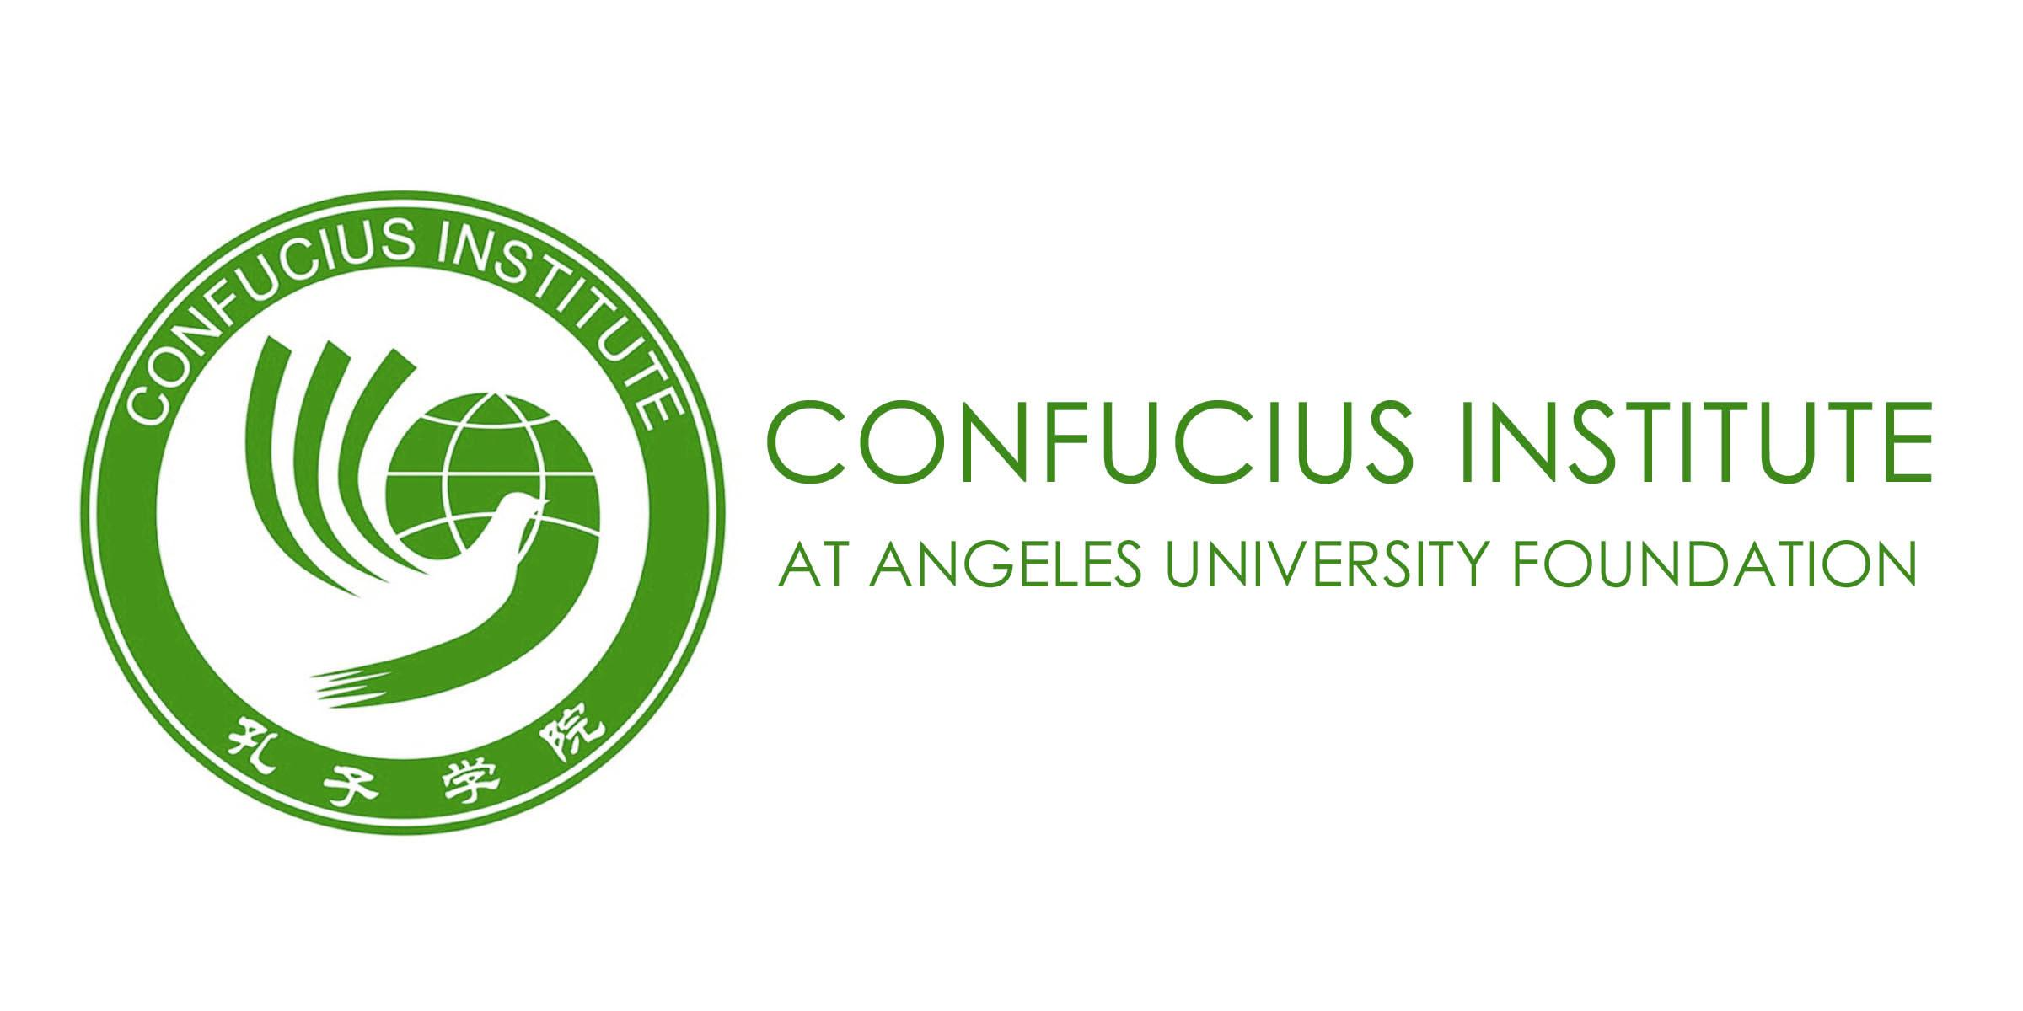
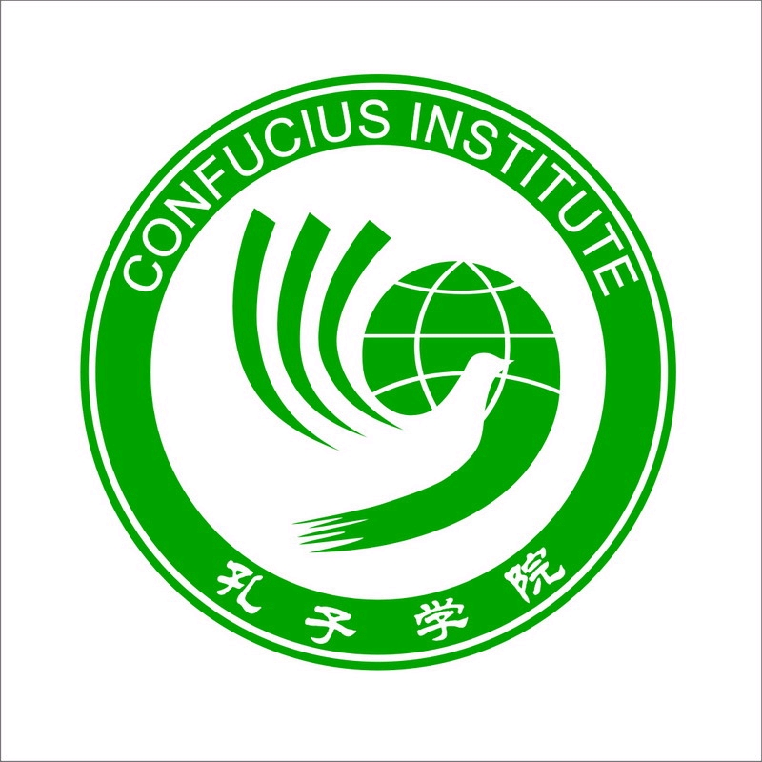

Metro Angeles Chamber of Commerce & Industry, Inc

THE PHILIPPINES AND CHINA IN THE GLOBAL ECONOMY:
PROSPECTS AND CHALLENGES
An Economic Briefing

June 26, 2010, Holiday Inn, Clark Freeport Zone, Pampanga
(Registration starts at 8:00 a.m.)

CONFIRMATION OF ATTENDANCE

ORGANIZATION: __________________________________________________________

ADDRESS: __________________________________________________________

TELEPHONE: ________________________ FAX: ______________________

WEBSITE: ________________________ E-MAIL: ___________________

PARTICIPANTS:
Name Position

- ___________________________________ ________________________________

- ___________________________________ ________________________________

- ___________________________________ ________________________________

4. ___________________________________ ________________________________

5. ___________________________________ ________________________________

Confirmed by:

_________________________________ _____________________ __________________
Signature Above Printed Name Position Date

Please fax to (045) 888-2624 not later than June 15, 2010.
Reservation is on a first-come, first-served basis.
THANK YOU.

